A : Output – R

Week 2: 1.2 Exercises: Charts

Shani Kumar

9/13/2020

## Week 2: 1.2 Exercises: Charts

You need to submit 3 bar charts, 3 stacked bar charts, 3 pie charts, and 3 donut charts using Tableau or PowerBI, Python and R using the data from the link below (the link will download a zipped folder containing three data files.) You may also use your own datasets if you wish. You can also submit using D3 if you choose – but it is not required. You can choose which library to use in Python or R, documentation is provided to help you decide and as you start to play around in the libraries, you will decide which you prefer.

**Data source** We are using dataset from [Data Source URL](https://content.bellevue.edu/cst/dsc/640/datasets/ex1-2.zip) file.

## Issue Approve Disapprove None  
## 1 Race Relations 52 38 10  
## 2 Education 49 40 11  
## 3 Terrorism 48 45 7  
## 4 Energy Policy 47 42 11  
## 5 Foreign Affairs 44 48 8  
## 6 Environment 43 51 6

### Data structure:

## 'data.frame': 13 obs. of 4 variables:  
## $ Issue : chr "Race Relations" "Education" "Terrorism" "Energy Policy" ...  
## $ Approve : num 52 49 48 47 44 43 41 41 40 38 ...  
## $ Disapprove: num 38 40 45 42 48 51 53 54 57 59 ...  
## $ None : num 10 11 7 11 8 6 6 5 3 3 ...

### Construct Charts:

**Bar Chart**

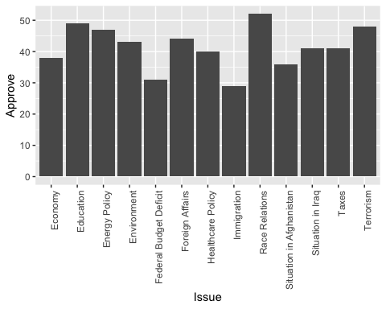

**Stacked Bar Chart**

Used melt to tranform dataset

## Using Issue as id variables

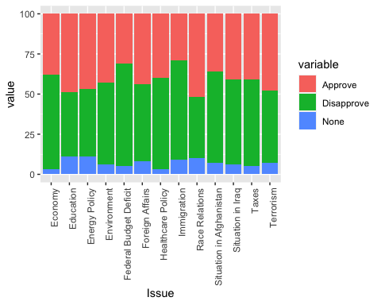

**Pie Chart : Issue Approve Rating**

To put the labels in the center of pies, I used cumsum(Approve) - 0.5*Approve as label position.

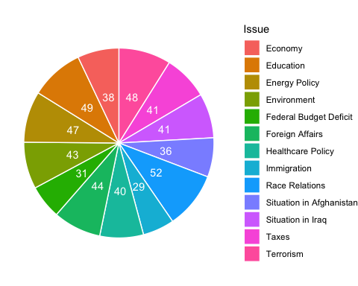

**Donut Chart : Issue Disapprove Rating**

To put the labels in the center of pies, I used cumsum(Disapprove) - 0.5*Disapprove as label position.

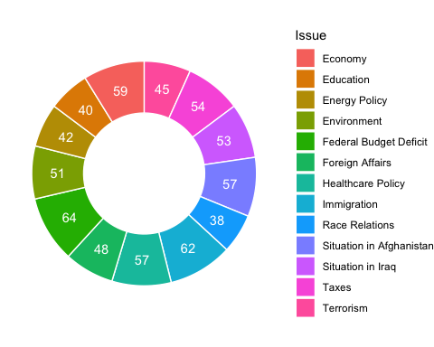

B: Output Python

# Week 2 - Assignment

**Prepare - Bar charts, Stacked bar charts, Pie charts, and Donut charts>**

**By**

**Shani Kumar**

### Introduction: Assignment Details

You need to submit 3 bar charts, 3 stacked bar charts, 3 pie charts, and 3 donut charts using Tableau or PowerBI, Python and R using the data from the link below (the link will download a zipped folder containing three data files.) You may also use your own datasets if you wish. You can also submit using D3 if you choose – but it is not required. You can choose which library to use in Python or R, documentation is provided to help you decide and as you start to play around in the libraries, you will decide which you prefer.

### Source Data

<https://content.bellevue.edu/cst/dsc/640/datasets/ex1-2.zip>

In [1]:

*# Impprt required libraries/packages*

**import** **numpy** **as** **np**

**import** **pandas** **as** **pd**

**import** **matplotlib.pyplot** **as** **plt**

*# configure display of graph*

%**matplotlib** inline

### Load data into a dataframe

In [2]:

*# load the csv file as a data frame*

obama_rating = pd.read_excel('ex1-2/obama-approval-ratings.xls')

*# summarize the shape of the dataset*

print("Dataset Shape: ",obama_rating.shape)

*# see the sample of the data*

print("**\n\n**Sample Data: ")

obama_rating.head()

Dataset Shape: (13, 4)

Sample Data:

Out[2]:

|  | **Issue** | **Approve** | **Disapprove** | **None** |
| --- | --- | --- | --- | --- |
| **0** | Race Relations | 52 | 38 | 10 |
| **1** | Education | 49 | 40 | 11 |
| **2** | Terrorism | 48 | 45 | 7 |
| **3** | Energy Policy | 47 | 42 | 11 |
| **4** | Foreign Affairs | 44 | 48 | 8 |

## Bar Chart

In [3]:

*# Plot bar chart*

plt.bar(obama_rating['Issue'], obama_rating['Approve'])

plt.xlabel('Issues')

plt.xticks(rotation=90)

plt.ylabel('Approved')

plt.title('Issues Approval Rating')

plt.show()

## Stacked Bar Chart

In [4]:

*# the first one is as usual*

p1 = plt.bar(obama_rating['Issue'], obama_rating['Approve'], color="GREEN")

*# the second to create stacked bar on top of p1*

p2 = plt.bar(obama_rating['Issue'], obama_rating['Disapprove'], bottom=obama_rating['Approve'], color="RED")

*# Set heights of p1 + p2*

bars = np.add(obama_rating['Approve'], obama_rating['Disapprove']).tolist()

*# the third one is special to create stacked bar plots on top of p1 + p2*

p3 = plt.bar(obama_rating['Issue'], obama_rating['None'], bottom=bars, color="BLACK")

*# Label & title setting*

plt.xticks(rotation=90)

plt.xlabel('Issues')

plt.ylabel('Rating')

plt.title('Omaha Issue Rating')

*# Legend setting*

plt.legend((p1, p2, p3), ('Approve', 'Disapprove', 'None'), loc='upper left',

bbox_to_anchor=(1.05, 1), borderaxespad=0.)

*# Show graph*

plt.show()

# Another way - Stacked Bar Chart

In [5]:

obama_rating = obama_rating.set_index('Issue')

p1 = obama_rating.plot(kind='bar', stacked=**True**, figsize=(10,8))

plt.ylabel('Rating')

plt.legend(loc='upper left', bbox_to_anchor=(1.05, 1), borderaxespad=0.)

plt.title('Obama Issue Rating')

plt.show()

## Pie Chart

In [6]:

*# Plot pie chart*

plot = obama_rating.plot.pie(y='Approve', figsize=(5, 5))

plt.legend(loc='upper left', bbox_to_anchor=(1.5, 1), borderaxespad=0.)

plt.title('Obama Issue Approval Rating')

*# Hide label text*

ax = plt.gca()

ax.axes.xaxis.set_visible(**False**)

ax.axes.yaxis.set_visible(**False**)

plt.show()

# Donut Chart

In [7]:

*# Plot pie chart*

plot = obama_rating.plot.pie(y='Approve', figsize=(5, 5))

plt.legend(loc='upper left', bbox_to_anchor=(1.5, 1), borderaxespad=0.)

plt.title('Obama Issue Approval Rating')

*# Hide label text*

ax = plt.gca()

ax.axes.xaxis.set_visible(**False**)

ax.axes.yaxis.set_visible(**False**)

*# add a circle at the center*

my_circle=plt.Circle( (0,0), 0.5, color='white')

p=plt.gcf()

p.gca().add_artist(my_circle)

plt.show()

In [ ]:

C: Output – Tableau

